Embryology Of The Heart&aorta
Through the 20thcentury , Knowledge of the events occurring during cardiac development was clouded by conflicting descriptions, coupled with use of notably different terminologies. Furthermore, not sll accounts were based on direct study of embryonic material,instead being constructed on the basis of interpretations of previous reports, supported by inferences made from the structure of the congenitally malformed heart. Such processes, in themselves, are understandable, since it is axiomatic that proper appreciation of the events occurring during formation of the heart will aid in the analysis of the morphogenesis of cardiac malformations, this being a desirable prerequisite in the search for optimal treatment (Sadler , 2010).
Over the past decade, this has all changed. There has an explosion of work, both anatomical and molecular, devoted to cardiac development. Advances in technology, coupled with the use of suitable animal models, now enable us to provide a more accurate account of the steps involved in formation and septation of the cardiac chambers. Not all of this new information is concordant with the "classical" accounts. In these reviews, therefore, we will describe, first, the steps involved in formation of the pimary heart tube, and its conversion to the four cardiac chambers and the primary heart tube, and its conversion to the four cadiac chambers and the paired arterial trunks, We will then look in greater detail at the events occurring during the separation of the initial solitary heart tube into discrete systemic and pulmonary circulation (Ronald and Dudek,2011).

Formation and development of the heart tube:
The mesodermal tissues that give rise to the heart first become evident when the embryo is undergoing the process known as "gastrulation". In the human, this occurs during the third week of development, while for the rats, at a comparable stage of development, around seven days will have elapsed from fertilization, and the embryo will be in the presomitic stage. The embryonic plate in humans, initially possessing two layers, is ovoid, and is formed at the union between the yolk sac and the amniotic cavity, In the midline of the long axis of the oval disc is found the primitive streak, with the node at its cranial end. Through this streak, cells migrate from the upper layer by the process called gastrulation to form the three germ layers of the embryo proper "The ectoderm., the endoderm, and the mesoderm "(Sadler,2010 ).
The mesoderm insinuates between the ectodermal and endodermal layers, which themselves are continuous with the amnion and yolk sac, respectively. Having insinuated, the mesoderm spreads laterally and cranially within the embryonic disc, ultimately giving rise to a variety of structures, such as the somites, which will produce the axial structures, and the lateral plate mesoderm, which will form the parietal body wall. The cells that are destined to form the heart are also derived from this mesodermal layer. They form a crescent virtually at the cranial border of the disc. As this heart forming achieves its crescentic shape, the central region of the ectoderm transforms into the neural plate. This folds become the neural tube, with the developing brain at its cranial end. In the human, the developing heart is initially cranial within the disc relative to the neural folds (Richard et al., 2017).
At this stage, the developing heart itself cosists of a plate of promyocardial cells, intermingled with a plexus of endothelial strands, also derived from the cardiac crescent. The cardiac plate is positioned inferior to the presumptive pericardial cavity, which has arisen as a space within the mesoderm. With continuing folding of the disc, this heart forming region is moved into the developing neck of the embryo. The folding inverts the orientation of the developing heart relative to the neural structures and the gut. Initially the cardiac plate was inferior to the pericardial cavity but, subsequent to folding, it also folds into a tube between the pericardial space and the newly formed foregut that then becomes surrounded by the pericardial space. The process of folding is driven by the massive growth of the cranial end of the neural tube as it forms the brain, couled with invagination of the endoderm to produce the foregut (Sadler,2010).
These events can now be visualized in animals such as the rats, with the cardiac structures demonstrated by the genes and proteins they contain. The location of the promyocardial cells can be determined from the outset by the expression of NKX 2.5, a master gene controlling cardiac development (Richard et al.,2017).
The cells can be then shown by a staining for sarcomeric proteins as they acquire a myocardial phenotype, revealing their location within the cardiac crescent. The arrangement is somewhat different in mouse compared to human, since the murine embryonic plate is cup-shaped rather than discoid, with the endoderm on the outside and the ectoderm on the inside of the cup (Sadler,2010).
Irrespective of the differences between spacies, the endothelial plexus, as described above, is formed at same time within the cardiac region and within the embryo, ensuring the presence of a circulatory system. In the cardiac region, this creates the primary endocardial tube of the heart. The endocardial cells forming the tube come from both side of the developing embryo and, as they form a lumen, are enveloped by myocardial cells, all this occurring within the newly formed pericardial cavity, The myocardium at this stage , however, does not completely surround the endothelial tube. Instead, it retains, in its dorsal aspect, continuity with the splanchnic mesoderm of the developing mediastinum, through the structure known as the dorsal mesocardium (Ronald and Dudek,2011)
At this stage, the forming heart is centrally positioned within the embryo, and is bilaterally symmetrical, taking the shape of an inverted Y . The two arms of the T, positioned inferiorly, are continuous with the developing venous tributaries of the embryo, yolk sac, and placenta, Making studies, however, have shown that the arms of the initial primary tube are fated to become the precursors of the atrial chambers, with the stem of the Y itself becoming the definitive left ventricle (Joukar et al., 2012).
It is only as the symmetrical arms of the tube are incorporated caudally into the heart to form the primary atrial component that there is formation also of a prominent junctional component, the atrioventricular canal (Sadler , 2010).
Subsequent to these changes, the venous tributaries then drain to either side of the newly formed atrium through the right and left sinus horns, This occurs in symmetrical fashion in the mouse but, when first seen in the human, the venous tributaries are already asymmetrical (Joukar et al., 2012).
At the stage when the system venous tribytaries are already seen draining to newly incorporated primary atrum, there is no formation of either the lungs or the pulmonary vein. Establishment of the pulmonary circulation, and its connection with the heart, is a later event in development (Ronald and Dudek,2011).
By this time, nonetheless, other important changes have been occurring at the cranial end of the heart tube. Cells from a second cardiogenic area, migrate into the cardiac region, where they make significant contributions to the developing cranial pole of the heart tube. The cells from this secondary heart field, first identified as a second crescent within the embryonic disc, lying contiguous with, but medial to , the primordium of the right ventricle (Sadler , 2010 ).
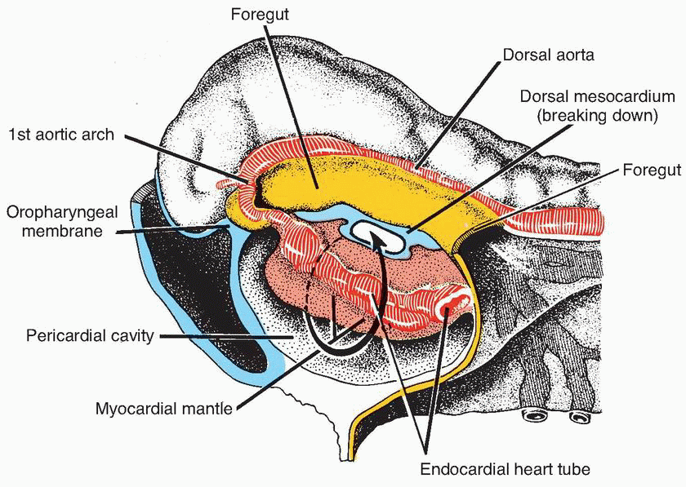
(Fig .4) Cephalic end of an early somite embryo. The developing endocardial heart tube and its investing layer bulge into the pericardial cavity. The dorsal mesocardium is breaking down (Sadler , 2010 ).
Looping of the heart tube:
These caudal and cranial addition to the tube produce a pronounced elongation of the primary heart tube. Associated with this elongation, the dorsal mesocardium, initially tethering the developing left ventricle to the mediastinum, undergoes distruption and liberates the larger part of the tube, Once liberated, the tube itself bends to the right as the start of the process known as looping. Looping of the heart tube is usually held to be the first visual evidence of asymmetry within the embryo, although the atrioventricular canal is itself formed in asymmetric fashion, with a bulge to the left (Joukar et al., 2012).
The signaling pathway that ensured that the loop bent to the right, however , is established earlier, during the stage of gastrulation. At this earlier stage , a leftward flow of secreted proteins across the node is the start of a least two separable pathways (Van den Brock et al.,2017).
Once formed, the ventricular loop itself has inlet and outlet components, with the outlet part supporting the outflow tract. The outflow tract, in turn, feeds the arteries that arise from the aortic sac and extended into the increasing number of pharyngeal arches (Sadler , 2010).
This arrangement is seen at around the 25th day in the human, the comparable situation being the 11th day in the rats, when where has been formation of about 40 somites. The stage is now set for formation of the definitive cardiac chambers, along with the arterial trunks (Richard et al.,2017).

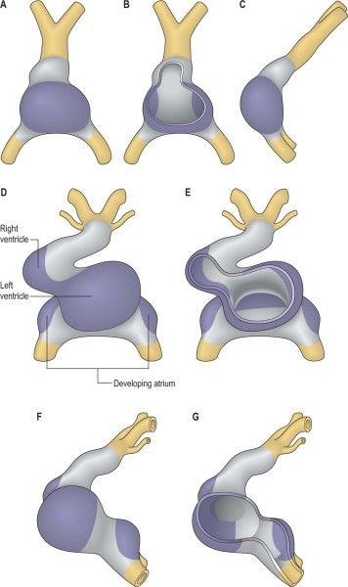
(Fig . 5 ) Local expansion of the myocardial wall of the early heart tube and heart tube looping A, ventral view; B, ventral wall removed to show inner aspect of the early heart tube; C, left lateral view. The early heart tube is shaped like an inverted ‘Y'. The legs of the Y pass caudal to each side of the cranial intestinal portal. In the early heart tube the myocardium of the stem of the Y (purple) contains only precursor cells for the left ventricle. The remaining myocardium (grey) contains only precursor cells for the atrioventricular canal and atria. The precursor left ventricular cells expand first. D–G: Later heart tube showing looping. D, Ventral view. E, Ventral wall removed to show inner aspect of the folding heart tube. F, Left lateral view. G, Lateral wall removed to show the inner aspect of the heart from the left. In D and E the expansion of the right ventricle can be seen and the heart tube has elongated to the right. The developing atrium can be seen dorsolaterally in D–G ( Sadler , 2010).

Formation of the cardiac chambers:
By the stage of looping, the primary heart tube wihin the pericardial cavity can be divided into atrial and ventricular components along with an outflow tract. The atrial and ventricular components are separated by the atrioventricular canal, which at this stage has significant length. The systemic venous tributaries, embedded in the substance of the posterior mediastinum, drain into the unseptated primary atrium. The blood flowing through the atrial component of the tube must, perforce, traverse the entirety of the ventricular loop so as to reach the outflow tract. This developing outflow component of the ventricular loop. By this stage, a constriction, which marks the site of the primary interventricular foramen, has developed between the inlet and outlet parts of the ventricular loop, which will become the left and right ventricles, respectively. The myocardial walls of the heart tube at this stage are formed of so –called primary myocardium (Joukar et al., 2012).
With further development, pronounced changes occur in all parts of the tube, so as to produce separate left and right components. These changes occur over the same period of time ,but, for convenience, we will describe them sequentially((Richard et al.,2017).
Formation of the atria :
Completion of the development of the left atrium requires formation of the lungs and pulmonary vasculature. The lungs themselves develop as outpouchings from the trachea. As the lung bud form, a plexus of vessels develops around them. The plexus establishes a connection with the primary atrial component of the heart tube via the pulmonary vein. Initially seen as an endothelial strand within the mediastinum, the initially solitary vein makes contact with the heart through the dorsal mesocadium(Doppler et al.,2017).
By this time, the asymmetry of the systemic venous tributaries has become exaggerated, with the left sinus horn, the developing pulmonary vein become incorporated in the left side of the atrioventricular junction but, opening into the right side of the primary atrium (Richard et al. ,2017).
Atrioventricular canal becomes incorporated into the definitive left atrium as the vestibule of the mitral valve (Van den Brock et al.,2017).
The pulmonary venous component, when first formed in the human, is relatively insignificant, since a solitary vein open inferiorly. Only subsequent to septation does the venous component expand to form the roof of the left atrium, eventually producing the definitive arrangement with four venous orifices (Doppler et al .,2017)).
Formation of the ventricles:
The ventricles are derived from the ventricular loop. Initially, the ventricular part of the primary tube was formed by the stem of the Y shaped heart tube, derived from the primary cardiac crescent, and by a distal part that received significant contributions from the secondary heart field. At this stage, all the blood from the atrial segment was required to pass through these two parts of the primary tube so as to reach the outflow tract, As the tube bent, the primary interventricular foramen become obvious between its own components. After looping, the tube itself has an inner and an outer curvature. Pronounced changes occur in both of these curves (Ronald and Dudek,2011).
The apical parts of the two ventricles balloon from the outer curve, with the inlet part of the primary tube giving rise to the developing apical part of the left ventricle, this occur before looping , and once formed, the new myocardium can readily be distinguished from the primary myocardium by its expression of atrial natriuretic factor (Joukar et al., 2012).
The apical part of the right ventricle appears subsequently, ballooning from the outlet limb of the primary tube. It is the trabeculations of these outpouchings that eventually give the definitive ventricles their characteristic morphology(Sadler , 2010).
Unlike the atrial chambers, the morphological differences between the two ventricles are not a reflection of left- right a symmetry. It is more likely that they reflect the spatio – temporal development of the ventricles in series within the ventricular component of primary heart tube (Doppler et al .,2017).
The changes that occur within the inner curve ensure that each apical part achieves its own inlet and outlet component. When ballooning of the apical components commences, the walls of the atrioventricular canal are joined almost exclusively to the developing left ventricle, while the outlet component of the heart tube is supported almost entirely by the developing right ventricle. At this stage, the myocardium surrounding the interventricular foramen itself, the so-called primary ring, can be distinguished within the primary myocardium by its expression of the GIN epitope (Sadler , 2010).
Tracing this primary ring over a period of time demonstrated the remodeling of the ventricular segment of the inner heart curvature, along with its junction with the atrioventricular canal proximally and the outlet component distally (Ronald and Dudek,2011).
This remodeling permits, the separating atriums, and the dividing outflow tract, to be shared between the developing apical components of the left and right ventricles. Sharing of the atriums between the ventricles requires expansion of the atrioventricular canal (Sadler , 2010).
From the outset, the wall of the developing right atrium is continuous in the inner curvature, via the primasry fold, with the wall of the outflow tract. All that is required for the cavity of the right atrium to achieve direct continuity with that of the cavity of the right ventricle, therefore, is expansion of the atrioventricular canal. Subsequent to expansion, and concomitant with the development of the insulating plane between the atrial and ventricular chambers, the musculature of the insulating plane between the atrial and ventricular chambers, the musculature of the right side of the atrioventricular canal itself, then becomes incorporated into the right atrium as the vestibule of the tricuspid valve (Joukar et al., 2012).
The inlet of the right ventricle, contiguous with the vestibule, continuous with the vestibule of the tricuspid valve, develops within the ventricular component of the primary heart tube, and the leaflets of the tricuspid valve delaminate from the myocardial walls of the primary tube, incorporating the endocardial cushions in their substance. The cavity of the left atrium is continuous with that of the developing left ventricle from the outset(Doppler et al .,2017).
As with the right side, the musculature of the atrioventricular canal becomes sequestrated within the atrium subsequent to formation of the atrioventricular plane of insulation, the leaflets of the mitral valve delaminating within the inlet component of the left ventricle in a fashion comparable to the formation of the tricuspid valve (Richard et al ,2017).
Completion of left ventricular development requires that half of the proximal part of the initial outflow tract be transferred from its initial location above the developing right ventricle to form the aortic vestibule, leaving the remainder of the outflow tract as the subpulmonary infundibulum. This change, obviously, requires that significant changes occur also within the outflow tract itself (Ronald and Dudek,2011).
Formation of the arterial trunks :
The outlet component of the primary heart tube, extending from the distal part of the ventricular loop to the distal extent of the pericardial cavity, where it joins the aortic sac, is initially a structure with exclusively myocardial walls, and with distal and proximal parts separated by a characteristic bend. Due to processes as yet undetermined, the walls of the distal outflow change rapidly from this myocardial phenotype to arterial one. Concomitant with the changes, the initially solitary tube seen distally is replaced by the interpericardial portions of the ascending aorta and the pulmonary trunk( Joukar et al., 2012).
The proximalpart also separates into two components,again losing its myocardial phenotype, with the arterial valvar leaflets and their supporting arterial sinuses formed just proximal to the bend, which marks the site of formation of the definitive sinutubular junctions. The most proximal part of the outflow tract is then itself separated by fusion of the cushions within it, new myocardium forming within the cushions to produce the medial part of the subpulmonary infundibulum, which retains its origin from the right ventricle (Richard et al.,2017).
At the same time, the subaortic part of the outflow segment is partitioned to the left ventricle by the fusion of the cushions to the crest of the muscular ventricular septum, the myocardium of the initial inner heart curvature eventually disappearing to permit fibrous continuity between the leaflets of the aortic and mitral valves in the ventricular roof (Sadler , 2010).

